Assignment 1
Q: Explain each of algorithm, flowchart and pseudocode, detailed construction of each. Draw symbols used in flowchart
Ans.
Algorithm:
An algorithm is defined as a finite sequence of instructions defining the solution of a particular problem, where each instruction is numbered.
However, in order to qualify as an algorithm, every sequence of instructions must satisfy the following criteria:
- Input: There are zero or more values which are externally supplied.
- Output: At least one value is produced.
- Definiteness: Each step must be clear and unambiguous, i.e., having one and only one meaning).
- Finiteness: If we trace the steps of an algorithm, then for all cases, the algorithm must terminate after a finite number of steps.
- Effectiveness: Each step must be sufficiently basic that it can in principle be carried out by a person using only paper and pencil. In addition, not only each step is definite, it must also be feasible.
Flowchart:
A flowchart is a pictorial representation of an algorithm. A flowchart uses different shapes to denote different types of instructions. The actual instructions are written within the shapes using clear and concise statements. These shapes are connected by directed lines to indicate the sequence in which instructions are to be executed.
Normally, an algorithm is first represented in the form of a flowchart and then the flowchart is expressed in some programming language to prepare a program.
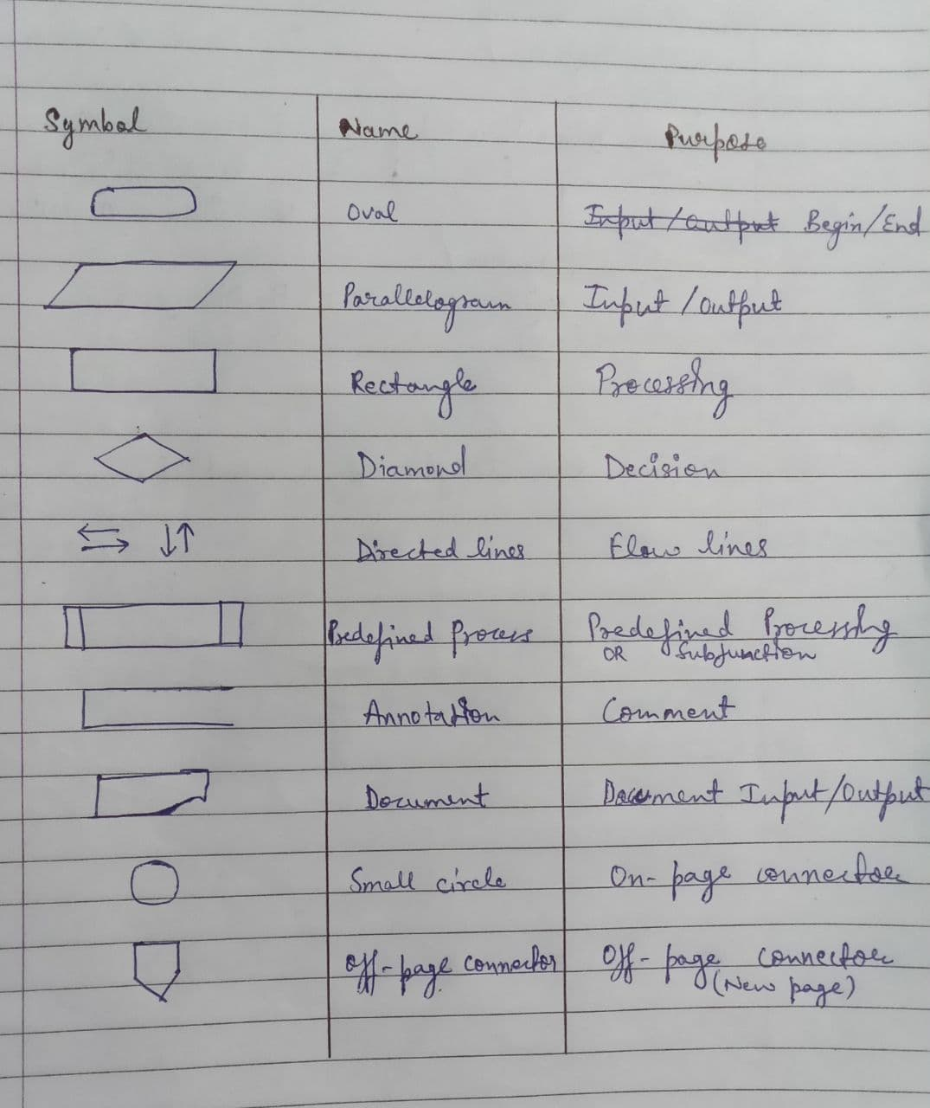

Pseudocode:
The word "pseudo" means imitation or false and the word "code" refers to the instruction written in a programming language. It is an imitation to actual computer instructions. Pseudo instructions are phrases written in English like statements.
Pseudocode uses a structure that resembles computer instructions. Because, it emphasizes the design of the program, pseudocode is also called Program Design Language (PDL).
Pseudocode is made up of the following basic logic structures that have proved to be sufficient for writing any computer program:
1. Sequence
2. Selection (if...then...Endif, If...then…Else…Endif )
3. Iteration (For...Endfor, While…Endwhile, Do . . . While)

Pseudocode Description
Comments:
Each instruction may be followed by a comment. The comments begin with a double slash, and the explain the purpose of the instruction, such as:
Read: n / Enter the value of variable n
Variable Name:
For variable names, we will use italicized lowercase letters such as max, loc, etc., whereas for defined constants, if any, we will use uppercase letters.

Assignment Statement:
The assignment statement will use the notation as
Set max = a;
to assign the value of a to max. The right hand side of the assignment statement can have a value, a variable or an expression. They are executed from left to right

Input/Output:
Data may be input and assigned to variables by means of a read statement with the following format
Read: Variable list
where the Variable list consists one or more variables separated by comma.
Similarly, the data held by the variables and the messages, if any, enclosed in double quotes can be output by means of a write statement with the following format
Print: message and/or Variable list
where the message and the variables in the Variable list are separated by comma.

Execution of Instructions:
The instructions in the pseudocode are usually executed one after the other as they appear in the pseudocode. However, there may be instances when some instructions are skipped or some instructions may be repeated as a result of certain expressions.

Completion of the Algorithm:
The pseudocode is completed with the execution of the last instruction. However, the pseudocode can be terminated at any intermediate state using the exit instruction.

